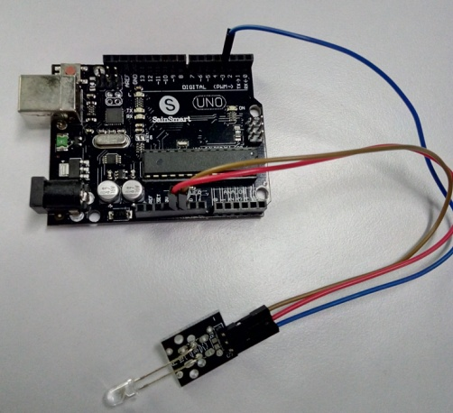

Main launch part code:

#include <IRremote.h>

IRsend irsend;

void setup()

{

Serial.begin(9600);

}

void loop() {

for (int i = 0; i < 50; i++) {

irsend.sendSony(0xa90, 12); // Sony TV power code

delay(40);

}

}

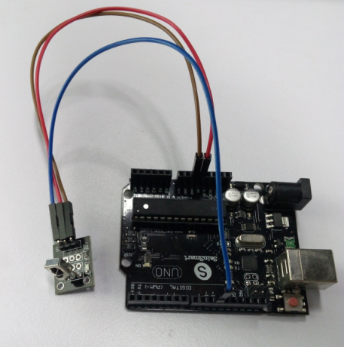

Receiving part code:

#include <IRremote.h>

int RECV_PIN = 11; //define input pin on Arduino

IRrecv irrecv(RECV_PIN);

decode_results results;

void setup()

{

Serial.begin(9600);

irrecv.enableIRIn(); // Start the receiver

}

void loop() {

if (irrecv.decode(&results)) {

Serial.println(results.value, HEX);

irrecv.resume(); // Receive the next value

}

}